**X Developer Challenge Team Background**

Welcome abroad! Did you know that the date of our X Developer Challenge is a palindrome? 🙂

For this challenge, let us build a cool feature for X and aim for the first place!

**Individual Intro:**

Your background and skills

* **Stefan Juang**
  + **Background:**

Hi all, I have a Computer Science background. I specialize in Game Theory and backend system pipeline such as deep learning model + database.

* + **Skills:**

Python, Vector Database, LLM.

**Brainstorm of Ideas:**

Pitch your idea here

What problem do you see? How do we tackle it? What would be our impact?

**Stefan Juang**

Welcome to the future of online debate. Transform online discussions on X with our debate

feature: *X-Arena*. This tool is designed to evolve our platform into a vibrant hub for

intellectual exchange.

**The Problem:**

Current online platforms often foster echo chambers rather than enlightening discussion, leaving

little room for exposure to differing viewpoints.

**Solution Proposition:**

Our innovative debate feature directly addresses this by

1. Connecting user’s posts to past discussions on similar topics.
2. Engage in Debate of Perspectives: Showcasing supporting and contrasting views beneath each user’s post.

**How It Works:**

Upon posting on Platform X, the system will:

1. Analytical Matching - Identifies and summarizes relevant past discussions using

(Tweet search + Grok) APIs

1. Display two curated responses under the user’s post via the Reply API

* Tweets supporting the user’s perspective.
* Tweets presenting contrasting views.

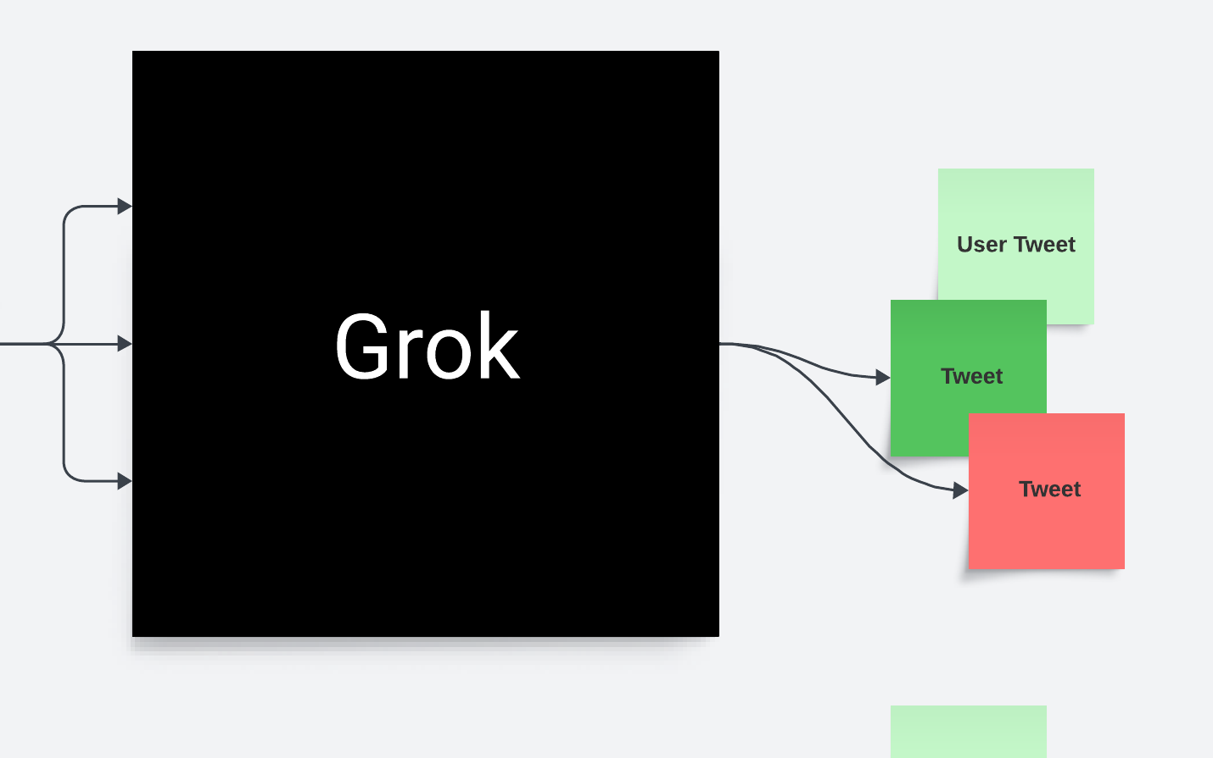

**Benefits:**

*X-Arena*’s dual-perspective approach not only provides comprehensive context to ongoing social

discussions but also engages users by exposing them to a spectrum of opinions, enhancing the

overall user experience and engagement on the platform.

**Closing:**

Let us transform dialogue on the X Platform. Building *X-Arena*, you become part of a platform

committed to enriching discourse and bridging divides. Let us build an engaging digital town

square together. And make every conversation count!

**Soham Mehta**

**Cloud, website setup**

**Hung Tran**

**D3**

**Neo**

Shiva:

Endpoints, react (frontend), communication of back and front end.

**Team Name / Logo Submission:**





Discussion:

**Resource Links:**

1. <https://developer.twitter.com/en/docs/platform-overview>
   1. X’s API documentation
2. <https://github.com/twitterdev/Twitter-API-v2-sample-code/tree/main>
   1. X’s API sample code
3. <https://developers.x.ai/python-sdk/ide/>
   1. XAI’s API documentation
4. <https://trello.com/b/myf7rKwV/twitter-developer-platform-roadmap>
5. X’s Developer Roadmp

**Twitter Data Analysis Tools:**

1. [Databox: Databox is an easy-to-use tool that can help you improve your Twitter analytics1](https://databox.com/best-twitter-analytics-tools). [It allows you to quickly and easily create custom dashboards with all the data you need to measure your success on Twitter1](https://databox.com/best-twitter-analytics-tools).
2. [Native Twitter Analytics: This is Twitter’s own analytics platform that provides a wide range of basic information1](https://databox.com/best-twitter-analytics-tools).
3. [Hootsuite: Hootsuite is a social media management platform that includes Twitter analytics features1](https://databox.com/best-twitter-analytics-tools).
4. [Sprout Social: Sprout Social is a social media management tool that provides detailed analytics on your Twitter performance1](https://databox.com/best-twitter-analytics-tools).
5. Keyhole: Keyhole is a real-time hashtag tracker for Twitter, Instagram, and Facebook. [It’s a great tool for tracking social media conversations and campaigns1](https://databox.com/best-twitter-analytics-tools).
6. [Twitonomy: Twitonomy offers a range of analytics with a user-friendly dashboard that includes details about your Twitter lists, followers, and tweets2](https://blog.wishpond.com/post/115675438033/free-twitter-analytics-tools).
7. [TweetReach: TweetReach is a great analytics tool for understanding how far your tweets travel1](https://databox.com/best-twitter-analytics-tools).

**Twitter Data Visualization Tools:**

1. [Tableau: Tableau is a powerful data visualization tool that can connect directly to Twitter through its Web Data Connector3](https://medium.com/analytics-vidhya/how-to-capture-analyse-and-visualize-twitter-data-19c8e5b0f87c).
2. [Twitter Archived Google Sheets (TAGS): TAGS is a free Google Sheet template which lets you setup and run automated collection of search results from Twitter3](https://medium.com/analytics-vidhya/how-to-capture-analyse-and-visualize-twitter-data-19c8e5b0f87c).
3. [Gephi: Gephi is a leading visualization and exploration software for all kinds of graphs and networks3](https://medium.com/analytics-vidhya/how-to-capture-analyse-and-visualize-twitter-data-19c8e5b0f87c). [It can be used for visualizing your Twitter network structure](https://databox.com/best-twitter-analytics-tools)[3](https://medium.com/analytics-vidhya/how-to-capture-analyse-and-visualize-twitter-data-19c8e5b0f87c).
4. [NodeXL: NodeXL is a template for Excel that lets you enter a network edge list, click a button, and see the network graph3](https://medium.com/analytics-vidhya/how-to-capture-analyse-and-visualize-twitter-data-19c8e5b0f87c).